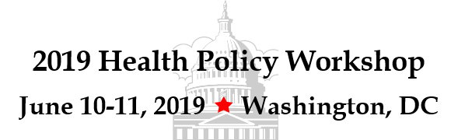

Application Form

Respond by

March 22, 2019

Use this Application to Register for the Health Policy Workshop and/or request a Travel Grant.
All Applicants must be approved prior to Registration.
Email completed Application Form to Janet Betts, janet.betts@annanurse.org

Full Name: |  |  | Credentials:
Home Address: |  |  | City: |  |  |  |  | State: |  | Zip:
Home Phone: |  |  | Cell:
Email: |  |  | Chapter Name and #:
ANNA Membership and Volunteer History
- List any ANNA volunteer roles you have held within the last 5 years:

- Membership Expiration Date: |  |  |  |  | (Expiration date must end after 3/31/20)

Previous Workshop Attendance / Advocacy Experience
- List any previous health policy workshops you have attended: (e.i. NIWI, ANNA Health Policy Workshop)
After attending, what did you do as a result?
- Describe your past and current advocacy efforts. What are some of the things you have done? (example: Congress Web or other letters, emails or visits to policy makers/legislators; Kidney Disease Awareness and Education (KDAE) week visits, Advocacy posts or advice via ANNA Connected, etc.)
- What are your goals for attending the 2019 Health Policy Workshop?
Goal #1:
Goal #2:
Goal #3:

- What is your plan for advocacy following the 2019 Health Policy Workshop? List at least three actions you are contemplating.
Action #1:
Action #2:
Action #3:

 | - Would you be willing to volunteer on behalf of ANNA and actively participate in advocacy efforts? |  |  |  |  | Yes |  | No |  |  | Maybe
 | - Do you have a good understanding of the basics for advocating with lawmakers and able to participate on a more advanced level? |  |  |  |  |  |  |  |  | Yes |  |  | No
 | - Do you feel you have enough experience and knowledge to help someone else advance as an advocate? |  |  |  |  |  |  |  |  | Yes |  |  | No
 | - Are you willing to complete a report of your experience and  the outcomes if selected to attend the 2019 Health Policy Workshop? |  |  |  |  |  |  |  |  | Yes |  |  | No
 | Travel Grant Request
 | - Do you wish to apply for a $750 Travel Grant?  (to be used for hotel and travel expenses only) |  |  |  |  |  |  |  |  | Yes |  |  | No
 | Indicate how you will travel to the Health Policy Workshop:
 |  |  | Plane | Closest Airport:
 |  |  | Car
 |  |  | Other – Please list:
A Travel Grant will not be paid if an airline ticket or hotel reservation does not meet the criteria listed in the 2019 Travel Grant Guidelines for Health Policy Workshop.
 | - Have you read the 2019 Travel Grant Guidelines and do you agree to follow all terms as written ? |  |  |  |  |  | Yes |  |  |  |  | No
References
Provide the names and contact information for two people who are familiar with your involvement or interest in health policy issues and advocacy efforts
 |  | Name |  |  | Email |  |  |  | Phone
 | 1.
 | 2.
Recommendation Letters
- Include a letter of recommendation from one of the references listed above.

Thank you for your interest in attending ANNA’s 2019 Health Policy Workshop. Email the completed application, along with a Letter of Recommendation to Janet Betts, janet.betts@annanurse.org by Friday, March 22, 2019. Applications will be reviewed and all applicants will be notified about the status of their application by April 1, 2019.

Application Submitted by (your typed name below indicates an electronic signature) :
Your Name: |  | Date:

